BAHRIA UNIVERSITY KARACHI CAMPUS
Department of Computer Science

APPLIED PHYSICS

LAB EXPERIMENT # 13

Meld’s Principle

OBJECTIVE:-

- To determine the frequency of AC supply Melde's apparatus.

EQUIPMENT:-

- Melde's apparatus (vibrograbh)
- AC supply.
- Pulley with stand.
- Two small optical pins with stands.
- Light string of about 3 meters.
- Pan.
- Weight box.
- Meter scale.

THEORY:-

The frequency of AC supply is given by;
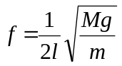

Where 'f' is the frequency of AC supply for frequency of transverse standing waves produced in string,

l is the distance between two successive nodes, i.e. equal to the length of a loop.
M is the total mass suspended to the string. i.e., mass placed in the pan plus mass of pan.
g is acceleration due to gravity, and m is mass per unit length of string.

PROCEDURE:-

- If the mass per unit length of string is not known, measure full length of string, say 2m, and weight it to the nearest milligram. Divide the measured mass by its length to get mass per unit length m of string. Note also the mass of pan m₁.
- One end of string is tied to the iron strip of vibrograph and the other end is passed over a frictionless pulley and is attached to a light pan (Fig-1). Take care that the pan does not touch the table or any other thing.
- Stretch the string by placing some mass m₂ say 20 gm, in the pan attached at end of string, and set vibrograph to vibrations by switching the current on.
- The length of the string is adjusted by moving vibrograph or position of vibrating strip is adjusted until standing waves having amplitude of about 1-2 cm are seen in the string.
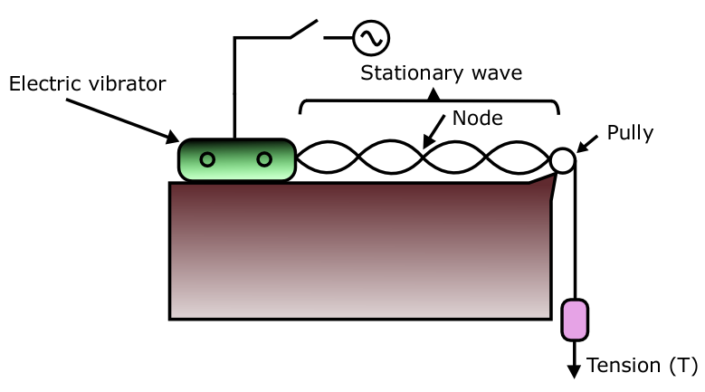
Fig: 2
- Now one optical pin is placed at the second and second last node formed in string and the distance L between these two optical pins measured by meter scale, and the string are not true nodes, and measurements should not be made from these points.
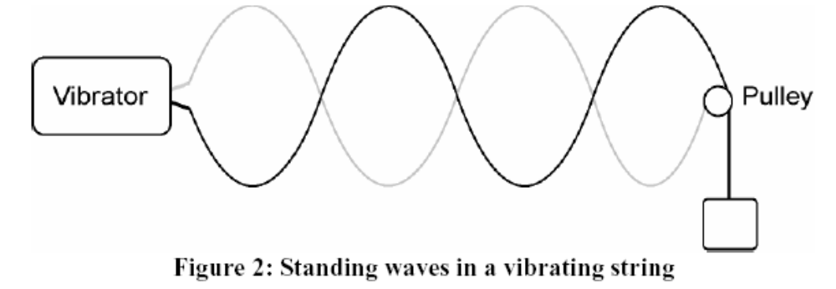
L
3
- Record the values of L and n and hence find out length of l of one loop.
- Alter the values of tension in string by changing weight in pan, say 30, 40, 50 and 100 gm, and repeat the operation five times for each weight to find L and n.
- Determine the frequency of AC supply in each case by using formula
And take the mean value.

OBSERVATIONS:-

- Mass per unit length of string = m = 0.0017 g/cm.
- Mass of pan = m₁ = ________________ g.

S# | Mass in pan  m2  gm | Total mass  M = m₁ + m₂  gm | No of Loops  n | Total length of n loops  L  cm | Length of one loop  L = L/n  cm | Frequency of AC  Hz or c/s | Mean frequency of AC  Hz or C/s
1
2
3
4
5

CALCULATIONS:-

The frequency of AC supply is given by;

= __________________ Hz.

RESULTS:-

- The frequency of AC supply = _________________ Hz.

PRECAUTIONS AND SOURCES OF ERRORS:-

- Vibrating strip or length of string should be so adjusted that the loops formed are sharp, stationary and of maximum amplitude.
- The pulley used should be frictionless and in line with the string.
- The string should be of uniform diameter.
- The pan should be light.
- The string and pan should be kept off the table.
- Optical pins should be carefully adjusted.

Teacher Signature: ________________________

Student Registration No: ________________________

